**ST. ANNE’S**

**COLLEGE OF ENGINEERING AND TECHNOLOGY**

(Approved by AICTE, New Delhi. Affiliated to Anna University, Chennai)

(An ISO 9001: 2015 Certified Institution)

ANGUCHETTYPALAYAM, PANRUTI – 607 106

**LAB MANUAL**

Regulation : 2017

Branch : *B.E.* – ECE

Year & Semester : III Year / V Semester





**EC8562-DIGITAL SIGNAL PROCESSING LABORATORY**

# ANNA UNIVERSITY CHENNAI

**Regulation 2017**

**EC8562-DIGITAL SIGNAL PROCESSING LABORATORY**

**LIST OF EXPERIMENTS:**

MATLAB / EQUIVALENT SOFTWARE PACKAGE

1. Generation of elementary Discrete-Time sequences

2. Linear and Circular convolutions

3. Auto correlation and Cross Correlation

4. Frequency Analysis using DFT

5. Design of FIR filters (LPF/HPF/BPF/BSF) and demonstrates the filtering operation

6. Design of Butterworth and Chebyshev IIR filters (LPF/HPF/BPF/BSF) and demonstrate the filtering operations

DSP PROCESSOR BASED IMPLEMENTATION

1. Study of architecture of Digital Signal Processor

2. Perform MAC operation using various addressing modes

3. Generation of various signals and random noise

4. Design and demonstration of FIR Filter for Low pass, High pass, Band pass and Band stop filtering

5. Design and demonstration of Butter worth and Chebyshev IIR Filters for Low pass, High pass, Band pass and

Band stop filtering

6. Implement an Up-sampling and Down-sampling operation in DSP Processor

TOTAL: 60 PERIODS

**INDEX**

# LIST OF EXPERIMENTS

|  |  |  |  |  |  |
| --- | --- | --- | --- | --- | --- |
| **S. No** | **Date** | **Name of the Experiment** | **Page no** | **Marks** | **Signature** |
| 1 |  | Generation of Discrete Time Signals |  |  |  |
| 2 |  | Correlation of Sequences |  |  |  |
| 3 |  | Linear and Circular Convolutions |  |  |  |
| 4 |  | Spectrum Analysis using DFT |  |  |  |
| 5a |  | Design of FIR Filters  (rectangular window design) |  |  |  |
| 5b |  | Design of FIR Filters (Hanning window design) |  |  |  |
| 6a |  | Design of IIR Butterworth Filters |  |  |  |
| 6b |  | Design of IIR Chebyshev Filters |  |  |  |
| 7 |  | Study of Architecture of Digital Signal Processor |  |  |  |
| 8 |  | MAC Operation using Various Addressing Modes |  |  |  |
| 9 |  | Generation of various signals and random noise |  |  |  |
| 10 |  | Design of FIR Filters |  |  |  |
| 11 |  | Design of IIR Filters |  |  |  |
| 12a |  | Up-sampling |  |  |  |
| 12b |  | Down-sampling |  |  |  |

**INTRODUCTION**

MATLAB is a software package for high performance numerical computation and visualization provides an interactive environment with hundreds of a built in functions for technical computation, graphics and animation. The MATLAB name stands for Matrix laboratory.

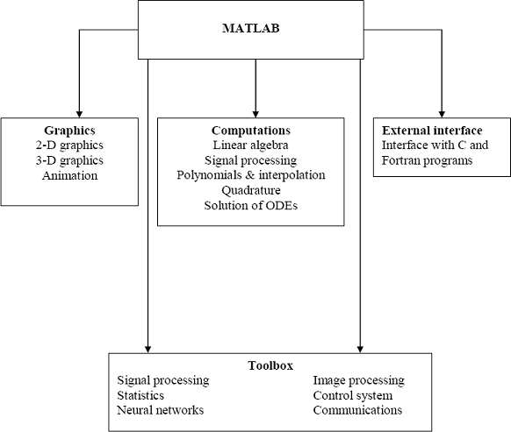

At its core, MATLAB is essentially a set (a “toolbox”) of routines (called “m files” or “mex files”) that sit on your computer and a window that allows you to create new variables with names (e.g. voltage and time) and process those variables with any of those routines (e.g. plot voltage against time, find the largest voltage, etc).

It also allows you to put a list of your processing requests together in a file and save that combined list with a name so that you can run all of those commands in the same order at some later time. Furthermore, it allows you to run such lists of commands such that you pass in data. and/or get data back out (i.e. the list of commands is like a function in most programming languages). Once you save a function, it becomes part of your toolbox. For those with computer programming backgrounds: Note that MATLAB runs as an interpretive language (like the old BASIC). That is, it does not need to be compiled. It simply reads through each line of the function, executes it, and then goes on to the next line.

# DSP Development System

* Testing the software and hardware tools with Code Composer Studio
* Use of the TMS320C6713 DSK
* Programming examples to test the tools

Digital signal processors such as the TMS320C6x (C6x) family of processors are like fast special-purpose microprocessors with a specialized type of architecture and an instruction set appropriate for signal processing. The C6x notation is used to designate a member of Texas Instruments’ (TI) TMS320C6000 family of digital signal processors. The architecture of the C6x digital signal processor is very well suited for numerically intensive calculations. Based on a very-long-instruction-word (VLIW) architecture, the C6x is considered to be TI’s most powerful processor. Digital signal processors are used for a wide range of applications, from communications and controls to speech and image processing. The general-purpose digital signal processor is dominated by applications in communications (cellular). Applications embedded digital signal processors are dominated by consumer products. They are found in cellular phones, fax/modems, disk drives, radio, printers, hearing aids, MP3 players, high-definition television (HDTV), digital cameras, and so on. These processors have become the products of choice for a number of consumer applications, since they have become very cost-effective. They can handle different tasks, since they can be reprogrammed readily for a different application.

DSP techniques have been very successful because of the development of low-cost software and hardware support. For example, modems and speech recognition can be less expensive using DSP techniques.DSP processors are concerned primarily with real-time signal processing. Real-time processing requires the processing to keep pace with some external event, whereas non-real-time processing has no such timing constraint. The external event to keep pace with is usually the analog input. Whereas analog-based systems with discrete electronic components such as resistors can be more sensitive to temperature changes, DSP-based systems are less affected by environmental conditions.

DSP processors enjoy the advantages of microprocessors. They are easy to use, flexible, and economical. A number of books and articles address the importance of digital signal processors for a number of applications .Various technologies have been used for real- time processing, from fiber optics for very high frequency to DSPs very suitable for the audio-frequency range. Common applications using these processors have been for frequencies from 0 to 96kHz. Speech can be sampled at 8 kHz (the rate at which samples are acquired), which implies that each value sampled is acquired at a rate of 1/(8 kHz) or 0.125ms. A commonly used sample rate of a compact disk is 44.1 kHz. Analog/digital (A/D)- based boards in the megahertz sampling rate range are currently available.

# Ex. No: 1 Date :

**GENERATION OF DISCRETE TIME SIGNALS**

**AIM:**

To generate a discrete time signal sequence (Unit step, Unit ramp, Sine, Cosine, Exponential, Unit impulse) using MATLAB function.

# APPARATUS REQUIRED:

HARDWARE : Personal Computer SOFTWARE : MATLAB

# PROCEDURE:

* 1. Start the MATLAB program.
  2. Open new M-file
  3. Type the program
  4. Save in current directory
  5. Compile and Run the program
  6. If any error occurs in the program correct the error and run it again
  7. For the output see command window\ Figure window
  8. Stop the program.

PROGRAMS: (GENERATION OF BASIC SIGNALS)

%Program for generation of unit impulse signal

t=-3:1:3;

y=[zeros(1,3),ones(1,1),zeros(1,3)];

Subplot (2, 2,1);

stem (t,y);

ylabel('amplitude');

xlabel('time period');

title('unit impulse')

%Program for generation of unit step signal

n=input('enter the sample length of unit step sequence');

t=0:1:n-1;

y=ones(1,n);

subplot(2,2,2);

stem(t,y);

ylabel('amplitude');

xlabel('sequence');

title('unit step')

%Program for generation of unit ramp signal

n1=input('enter the sample length of unit ramp sequence');

t=0:n1;

subplot(2,2,3);

stem(t,t);

ylabel('amplitude');

xlabel('sequence');

title('unit ramp')

%Program for generation of discrete exponential signal:

n2=input('enter the length of the exponential sequence');

t=0:n2;

a=input('enter the a value');

y2=exp(a*t);

subplot(2,2,4);

stem(t,y2);

ylabel('amplitude');

xlabel('time period');

title('exponential sequence')

%Program for generation of continuous exponential signal:

n3=input('enter the length of the exponential sequence');

t=0:2:n3-1;

a=input('enter the a value');

y3=exp(a*t);

subplot(3,1,1);

stem(t,y3);

ylabel('amplitude');

xlabel('time period');

title('continuous exponential sequence')

%Program for generation of sine wave

t=0:0.01: pi;

y=sin(2*pi*t);

subplot(3,1,2);

stem(t,y);

ylabel('amplitude');

xlabel('time period');

title('sine wave')

%Program for generation of cosine wave

t=0:0.01: pi;

y=cos(2*pi*t);

subplot(3,1,3);

stem(t,y);

ylabel('amplitude');

xlabel('time period');

title('cosine wave')

OUTPUT: (DISCRETE SIGNALS)

Enter the sample length of unit step sequence 8

Enter the length of ramp sequence 6

Enter the length of the exponential sequence 8

Enter the a value 5



OUTPUT: (CONTINUOUS SIGNALS)

Enter the length of continuous exponential sequence 10

Enter the a value 5



**RESULT:**

Thus the MATLAB programs for discrete time signal sequence (Unit step, Unit ramp, Sine, Cosine, Exponential, Unit impulse) using MATLAB function written and the results were plotted.

# Ex. No: 2

**Date:**

**AIM:**

**CORRELATION OF SEQUENCES**

To write MATLAB programs for auto correlation and cross correlation.

# APPARATUS REQUIRED:

HARDWARE : Personal Computer SOFTWARE : MATLAB R2014a

# PROCEDURE:

1. Start the MATLAB program.
2. Open new M-file
3. Type the program
4. Save in current directory
5. Compile and Run the program
6. If any error occurs in the program correct the error and run it again
7. For the output see command window\ Figure window
8. Stop the program.

# PROGRAM: (Cross-Correlation of the Sequences)

clc;

clear all;

close all;

x=input('Enter the sequence 1: ');

h=input('Enter the sequence 2: ');

y=xcorr(x,h);

figure;

subplot(3,1,1); stem(x);

xlabel('n->');

ylabel('Amplitude->');

title('Input sequence 1');

subplot(3,1,2);

stem(fliplr(y));

stem(h);

xlabel('n->');

ylabel('Amplitude->');

title('Input sequence 2');

subplot(3,1,3);

stem(fliplr(y));

xlabel('n->');

ylabel('Amplitude->');

title('Output sequence');

disp('The resultant is');

fliplr(y);

OUTPUT: (Cross-Correlation of the Sequences)

Enter the sequence 1: [1 3 5 7]

Enter the sequence 2: [2 4 6 8]

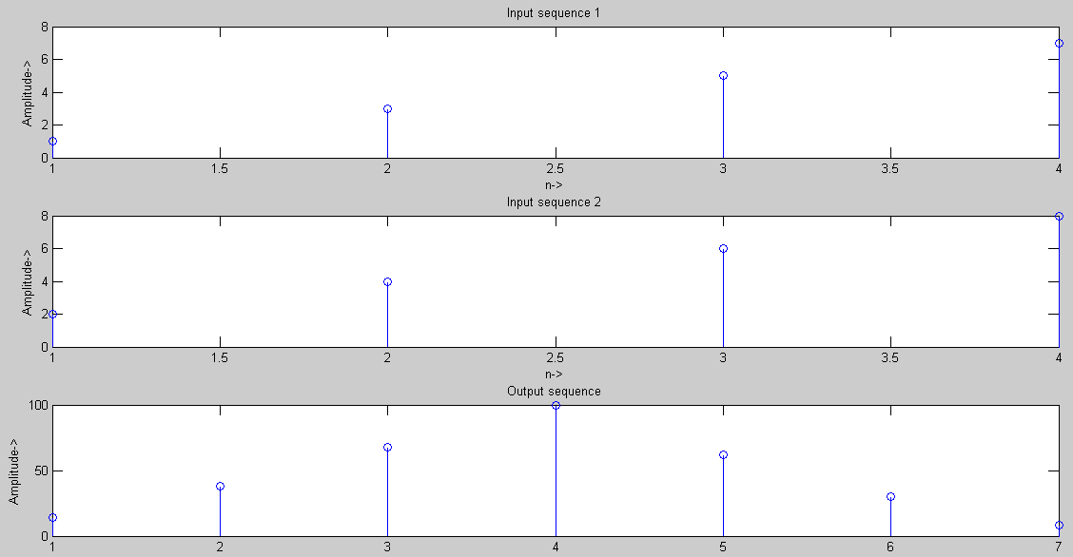

**PROGRAM: (Auto Correlation Function)**

clc;

close all;

clear all;

x=input('Enter the sequence 1: ');

y=xcorr(x,x);

figure;

subplot(2,1,1);

stem(x);

ylabel('Amplitude->');

xlabel('n->');

title('Input sequence');

subplot(2,1,2);

stem(fliplr(y));

ylabel('amplitude');

xlabel('n->');

title('Output sequence');

disp('the resultant is ');

fliplr(y);

**OUTPUT: (Auto Correlation Function)**

**Enter the sequence [1 2 3 4]**

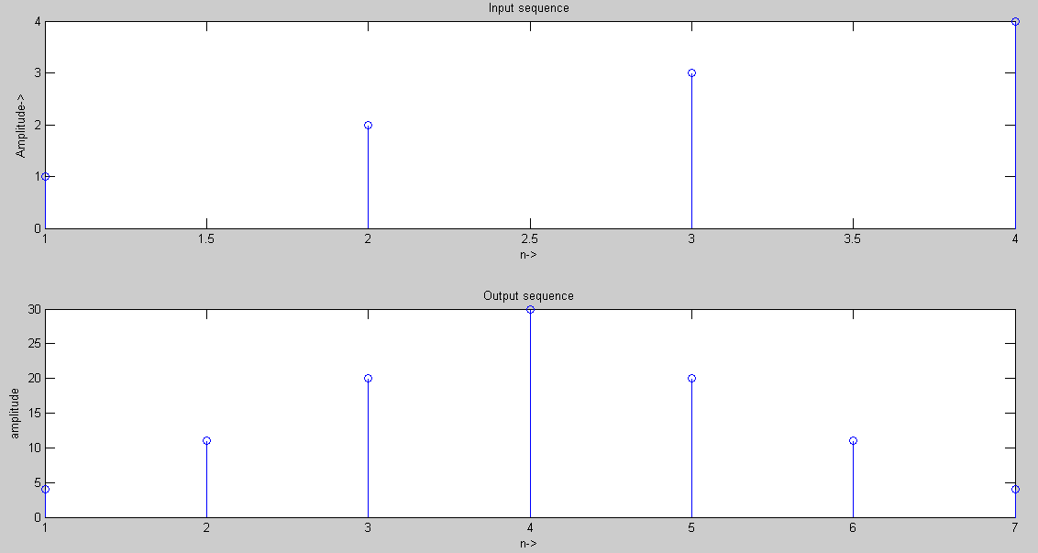

**RESULT:**

Thus the MATLAB programs for auto correlation and cross correlation written and the results were plotted.

# Ex. No: 3

**Date:**

**AIM:**

**LINEAR AND CIRCULAR CONVOLUTIONS**

To write MATLAB programs to find out the linear convolution and Circular convolution of two sequences.

# APPARATUS REQUIRED:

HARDWARE : Personal Computer SOFTWARE : MATLAB R2014a

# PROCEDURE:

* 1. Start the MATLAB program.
  2. Open new M-file
  3. Type the program
  4. Save in current directory
  5. Compile and Run the program
  6. If any error occurs in the program correct the error and run it again
  7. For the output see command window\ Figure window
  8. Stop the program.

%Program for linear convolution

%to get the input sequence

n1=input('enter the length of input sequence');

n2=input('enter the length of impulse sequence');

x=input('enter the input sequence');

h=input('enter the impulse sequence');

%convolution operation

y=conv(x,h);

%to plot the signal

subplot(3,1,1);

stem(x);

ylabel('amplitude');

xlabel('n1....>');

title('input sequence')

subplot(3,1,2);

stem(h);

ylabel('amplitude');

xlabel('n2....>');

title('impulse signal')

subplot(3,1,3);

stem(y);

ylabel('amplitude');

xlabel('n3');

disp('the resultant signal is');y

%circular convolution

clc;

clear all;

close all;

%to get the input sequence

g=input('enter the input sequence');

h=input('enter the impulse sequence');

N1=length(g);

N2=length(h);

N=max(N1,N2);

N3=N1-N2

%loop for getting equal length sequence

if(N3>=0)

h=[h,zeros(1,N3)];

else

g=[g,zeros(1,-N3)];

end

%computation of circular convoluted sequence

for n=1:N;

y(n)=0;

for i=1:N;

j=n-i+1;

if(j<=0)

j=N+j;

end

y(n)=y(n)+g(i)*h(j);

end

end

figure;

subplot(3,1,1);

stem(g);

ylabel('amplitude');

xlabel('n1..>');

title('input sequence')

subplot(3,1,2);

stem(h);

ylabel('amplitude');

xlabel('n2');

title('impulse sequence')

subplot(3,1,3);

stem(y);

ylabel('amplitude');

xlabel('n3');

disp('the resultant signal is');

OUTPUT : LINEAR CONVOLUTION

Enter the length of input sequence 4

Enter the length of impulse sequence 4

Enter the input sequence [1 2 3 4]

Enter the impulse sequence [4 3 2 1]

The resultant signal is

y= 4 11 20 30 20 11 4



OUTPUT : CIRCULAR CONVOLUTION

Enter the input sequence [1 2 2 1]

Enter the impulse sequence [4 3 2 1]

The resultant signal is

y= 15 17 15 13



**RESULT:**

Thus the MATLAB

programs for linear convolution and circular convolution

written and the results were plotted.

# Ex. No: 4

**Date: AIM:**

**FREQUENCY ANALYSIS USING DFT**

To write MATLAB program for Frequency analyzing signal using DFT.

# APPARATUS REQUIRED:

HARDWARE : Personal Computer SOFTWARE : MATLAB

# PROCEDURE:

* 1. Start the MATLAB program.
  2. Open new M-file
  3. Type the program
  4. Save in current directory
  5. Compile and Run the program
  6. If any error occurs in the program correct the error and run it again
  7. For the output see command window\ Figure window
  8. Stop the program.

PROGRAM: (COMPUTATION OF FFT OF A SIGNAL)

%program for computation of fft

Clear all;

Close all;

xn=input('enter the input sequence');

n=input ('enter the number of points in fft');

l=length (xn);

if (n<1)

disp (n>=1);

end

xk=fft(xn,n);

stem(xk);

xlabel('real axis');

ylabel('imaginary axis');

title('fft');

disp('the values....');xk

OUTPUT: (FFT)

Enter the input sequence [2 1 2 1 2 1 2 1]

Enter the number of points in fft 8

The values ….

Xk= 12 0 0 0 4 0 0 0



# PROGRAM: (Spectrum Analysis Using DFT)

N=input('type length of DFT= ');

T=input('type sampling period= ');

freq=input('type the sinusoidal freq= ');

k=0:N-1;

f=sin(2*pi*freq*1/T*k); F=fft(f); stem(k,abs(F));

grid on; xlabel('k');

ylabel('X(k)');

**INPUT:**

type length of DFT=32 type sampling period=64

type the sinusoidal freq=11

**OUTPUT: (Spectrum Analysis Using DFT)**

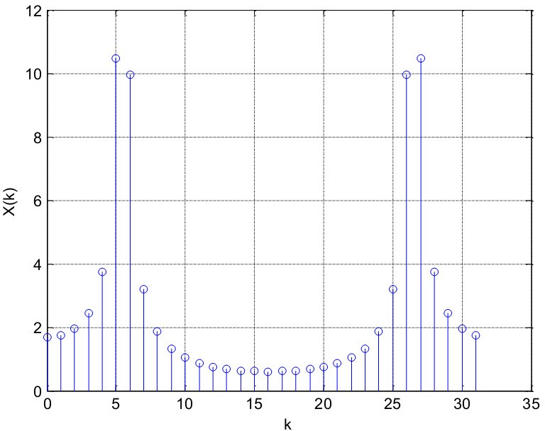

**RESULT:**

Thus the Spectrum Analysis of the signal using DFT is obtained using MATLAB.

# Ex. No: 5a Date:

**AIM:**

**DESIGN OF FIR FILTERS (RECTANGULAR WINDOW DESIGN)**

To write a program to design the FIR low pass, High pass, Band pass and Band stop filters using RECTANGULAR window and find out the response of the filter by using MATLAB.

# APPARATUS REQUIRED:

HARDWARE : Personal Computer SOFTWARE : MATLAB R2014a

# PROCEDURE:

1. Start the MATLAB program.
2. Open new M-file
3. Type the program
4. Save in current directory
5. Compile and Run the program
6. If any error occurs in the program correct the error and run it again
7. For the output see command window\ Figure window
8. Stop the program.

# PROGRAM: (Rectangular Window)

%program for the design of FIR low pass, high pass, band pass and band stop

filter using rectangular window

clc;

clear all;

close all;

rp=input('enter the passband ripple');

rs=input('enter the stopband ripple');

fp=input('enter the passband frequency');

fs=input('enter the stopband frequency');

f=input('enter the sampling frequency');

wp=2*fp/f;

ws=2*fs/f;

num=-20*log10(sqrt(rp*rs))-13;

dem=14.6*(fs-fp)/f;

n=ceil(num/dem);

n1=n+1;

if(rem(n,2)~=0)

n1=n;

n=n-1;

end;

y=boxcar(n1);

%lowpass filter

b=fir1(n,wp,y);

[h,o]=freqz(b,1,256);

m=20*log10(abs(h));

subplot(2,2,1);

plot(o/pi,m);

ylabel('gain in db....>');

xlabel('(a)normalized frequency.....>');

%highpass filter

b=fir1(n,wp,'high',y);

[h,o]=freqz(b,1,256);

m=20*log10(abs(h));

subplot(2,2,2);

plot(o/pi,m);

ylabel('gain in db......>');

xlabel('(b)normalized frequency......>');

%bandpass filter

wn=[wp ws];0

b=fir1(n,wn,y);

[h,o]=freqz(b,1,256);

m=20*log10(abs(h));

subplot(2,2,3);

plot(o/pi,m);

ylabel('gain in db....>');

xlabel('(c)normalized frequency....>');

%bandstop filter

b=fir1(n,wn,'stop',y);

[h,o]=freqz(b,1,256);

m=20*log10(abs(h));

subplot(2,2,4);

plot(o/pi,m);

ylabel('gain in db....>');

xlabel('(d)normalized frequency.....>');

**OUTPUT: (Rectangular Window)**

Enter the pass band ripple 0.03

Enter the stop band ripple 0.01

Enter the pass band frequency 1400

Enter the stop band frequency 2000

Enter the sampling frequency 8000

MAGNITUDE RESPONSE OF LPF 50

MAGNITUDE RESPONSE OF HPF 50

0 0

G a in in d b--------.

G a in in d b--------.

-50 -50

-100

0 0.5 1

Normalized freqency------>

-100

0 0.5 1

Normalized freqency------>

MAGNITUDE RESPONSE OF BPF 50

MAGNITUDE RESPONSE OF BSF 20

0

G a in in d b--------.

-50

0

-20

G a in in d b--------.

-40

-100

0 0.5 1

Normalized freqency------>

-60

0 0.5 1

Normalized freqency------>

# RESULT:

Thus the program to design FIR low pass, high pass, band pass and band stop Filters using RECTANGULAR Window was written and response of the filter using MATLAB was executed.

# Ex. No: 5b Date:

**AIM:**

**DESIGN OF FIR FILTERS (HANNING WINDOW DESIGN)**

To write a program to design the FIR low pass, High pass, Band pass and Band stop filters using HANNING window and find out the response of the filter by using MATLAB.

# APPARATUS REQUIRED:

HARDWARE : Personal Computer SOFTWARE : MATLAB R2014a

# PROCEDURE:

1. Start the MATLAB program.
2. Open new M-file
3. Type the program
4. Save in current directory
5. Compile and Run the program
6. If any error occurs in the program correct the error and run it again
7. For the output see command window\ Figure window
8. Stop the program.

# PROGRAM: (Hanning Window)

%program for the design of FIR lowpass, high pass, band pass, band stop filter

using hanning window

clc;

clear all;

close all;

rp=input('enter the passband ripple');

rs=input('enter the stopband ripple');

fp=input('enter the passband frequency');

fs=input('enter the stopband frequency');

f=input('enter the sampling frequency');

wp=2*fp/f;

ws=2*fs/f;

num=-20*log10(sqrt(rp*rs))-13;

dem=14.6*(fs-fp)/f;

n=ceil(num/dem);

n1=n+1;

if(rem(n,2)~=0)

n1=n;

n=n-1;

end;

Y=hanning(n1);

%lowpass filter

b=fir1(n,wp,Y);

[h,o]=freqz(b,1,256);

m=20*log10(abs(h));

subplot(2,2,1);

plot(o/pi,m);

ylabel('gain in db....>');

xlabel('(a)normalized frequency');

%highpass filter

b=fir1(n,wp,'high',Y);

[h,o]=freqz(b,1,256);

m=20*log10(abs(h));

subplot(2,2,2);

plot(o/pi,m);

ylabel('gain in db...>');

xlabel('(b)normalized frequency...>');

%bandpass filter

wn=[wp ws];

b=fir1(n,wn,Y);

[h,o]=freqz(b,1,256);

m=20*log10(abs(h));

subplot(2,2,3);

plot(o/pi,m);

ylabel('gain in db.....>');

xlabel('(c)normalized frequency....>');

%bandstop filter

b=fir1(n,wn,'stop',Y);

[h,o]=freqz(b,1,256);

m=20*log10(abs(h));

subplot(2,2,4);

plot(o/pi,m);

ylabel('gain in db...>');

xlabel('(d)normalized frequency....>')

FIR : ( HAMMING WINDOW)

Enter the pass band ripple 0.03

Enter the stop band ripple 0.01

Enter the pass band frequency 1400

Enter the stop band frequency 2000

Enter the sampling frequency 8000

MAGNITUDE RESPONSE OF LPF 50

MAGNITUDE RESPONSE OF HPF 50

0

Gain in db--------.

-50

-100

0

-50

Gain in db--------.

-150

0 0.5 1

Normalized freqency------>

-100

0 0.5 1

Normalized freqency------>

MAGNITUDE RESPONSE OF BPF 0

MAGNITUDE RESPONSE OF BSF 5

0

Gain in db--------.

Gain in db--------.

-50

-5

-100

0 0.5 1

Normalized freqency------>

-10

0 0.5 1

Normalized freqency------>

# RESULT:

Thus the program to design FIR low pass, high pass, band pass and band stop Filters using **HANNING** Window was written and response of the filter using **MATLAB** was executed.

# Ex. No: 6

**Date:**

**AIM:**

**DESIGN OF IIR FILTERS**

To write a program to design the IIR Butterworth & Chebyshew Filter (LPF/HPF/BPF/BSF) by using MATLAB.

# APPARATUS REQUIRED:

HARDWARE : Personal Computer SOFTWARE : MATLAB R2014a

# PROCEDURE:

1. Start the MATLAB program.
2. Open new M-file
3. Type the program
4. Save in current directory
5. Compile and Run the program
6. If any error occurs in the program correct the error and run it again
7. For the output see command window\ Figure window
8. Stop the program.

# PROGRAM: (IIR Butterworth Filter)

PROGRAMS: IIR (BUTTERWORTH FILTER)

% Butterworth filter

% get the input values

rp=input('enter the passband ripple');

rs=input('enter the stopband ripple');

wp=input('enter the passband frequency');

ws=input('enter the stopband frequency');

fs=input('enter the sampling frequency');

w1=2*wp/fs;

w2=2*ws/fs;

%filter order

[n,wn]=buttord(w1,w2,rp,rs);

%lowpass filter

%either coefficient

[b,a]=butter(n,wn);

%frequency response

[h,w]=freqz(b,a,512);

subplot(2,2,1);

plot(w,abs(h));

xlabel('normalized frequency');

ylabel('abs(h)');

title('lpf')

%high pass filter

%filter coefficient

[b,a]=butter (n,wn,'high');

%frequency response

[h,w]=freqz(b,a,512);

subplot(2,2,2);

plot(w,abs(h));

xlabel('normalised frquency');

ylabel('abs(h)');

title('hpf')

%band pass filter

%filter coefficient

wn1=[w1 w2];

[b,a]=butter(n,wn1);

%frequency response

[h,w]=freqz(b,a,512);

subplot(2,2,3);

plot(w,abs(h));

xlabel('normalised frequency');

ylabel('abs(h)');

title('bpf')

%band pass filter

%filter coefficient

wn2=[w1 w2];

[b,a]=butter(n,wn2,'stop');

%frequency response

[h,w]=freqz(b,a,512);

subplot(2,2,4);

plot(w,abs(h));

xlabel('normalised frequency');

ylabel('abs(h)');

title('bsf')

IIR : (BUTTERWORTH FILTER)

Enter the pass band ripple 6

Enter the stop band ripple 25

Enter the pass band frequency 1300

Enter the stop band frequency 3000

Enter the sampling frequency 8000



PROGRAMS: IIR (CHEBYSHEW FILTER)

% chebyshew filter

% get the input values

rp=input('enter the passband ripple');

rs=input('enter the stopband ripple');

wp=input('enter the passband frequency');

ws=input('enter the stopband frequency');

fs=input('enter the sampling frequency');

w1=2*wp/fs;

w2=2*ws/fs;

%filter order

[n,wn]=cheb1ord(w1,w2,rp,rs);

%lowpass filter

%either coefficient

[b,a]=cheby1(n,rp,wn);

%frequency response

[H,w]=freqz(b,a,512);

subplot(2,2,1);

plot(w,abs(H));

xlabel('normalised frequency');

ylabel('abs(H)');

title('LPF')

%high pass filter

%filter coefficient

[b,a]=cheby1(n,rp,wn,'High');

%frequency response

[H,w]=freqz(b,a,512);

subplot(2,2,2);

plot(w,abs(H));

xlabel('normalised frequency');

ylabel('abs(H)');

title('HPF')

%band pass filter

%filter coefficient

wn1=[w1,w2];

[b,a]=cheby1(n,rp,wn1);

%frequency response

[H,w]=freqz(b,a,512);

subplot(2,2,3);

plot(w,abs(H));

xlabel('normalised frequency');

ylabel('abs(H)');

title('BPF')

%band stop filter

%filter coefficient

wn2= [w1, w2];

%frequency response

[b,a]=cheby1(n,rp,wn2,'stop');

[H,w]=freqz(b,a,512);

subplot(2,2,4);

plot(w,abs(H));

xlabel('normalised frequency');

ylabel('abs(H)');

title('BSF')

IIR : (CHEBYSHEW FILTER)

Enter the pass band ripple 6

Enter the stop band ripple 25

Enter the pass band frequency 1300

Enter the stop band frequency 3000

Enter the sampling frequency 8000



# RESULT:

Thus the program to design IIR Butterworth & Chebyshew Filter (LPF/HPF/BPF/BSF) by using MATLAB was executed.

**DSP PROCESSOR EXPERIMENTS**

# PROCEDURE TO WORK ON CODE COMPOSER STUDIO

1. **To create a New Project**

Project →New (SUM.pjt)

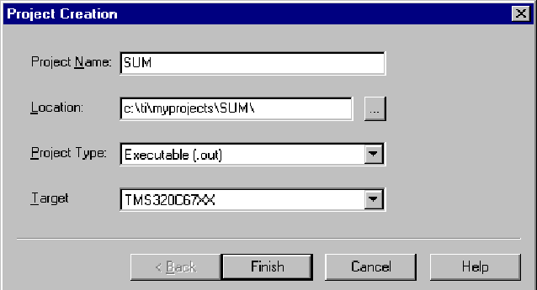

# To Create a Source file

File → New

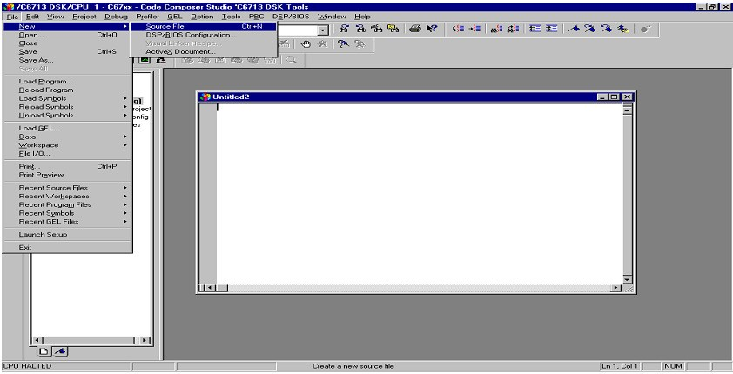

Type the code (Save & give a name to file, Eg: sum.c).

# To Add Source files to Project

Project → Add files to Project → sum.c

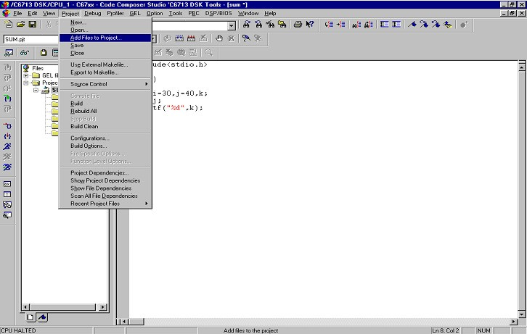

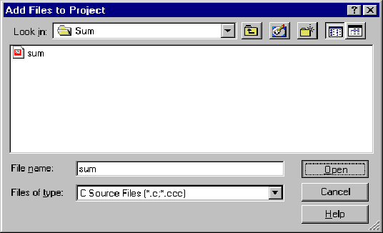

# To Add rts6700.lib file & hello.cmd:

Project →Add files to Project →rts6700.lib Path: c:\CCStudio\c6000\cgtools\lib\rts6700.lib

Note: Select Object & Library in(*.o,*.l) in Type of files Project →Add files to Project →hello.cmd

Path: c:\ti\tutorial\dsk6713\hello1\hello.cmd

Note: Select Linker Command file(*.cmd) in Type of files

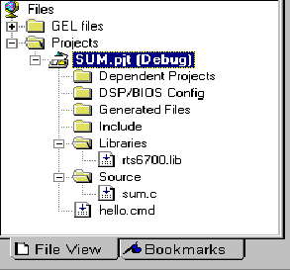

# To Compile:

Project → Compile File

1. **To build or Link**: Project → build,

Which will create the final executable (.out) file.(Eg. sum.out).

# Procedure to Load and Run program:

Load program to DSK:

File →Load program →sum. Out

# To execute project:

Debug →Run.

# Ex. No: 7

**Date:**

**STUDY OF ARCHITECTURE OF DIGITAL SIGNAL PROCESSOR**

**AIM:**

To study the Architecture of TMS320VC67XX DSP processor.

# INTRODUCTION

The hardware experiments in the DSP lab are carried out on the Texas Instruments TMS320C6713 DSP Starter Kit (DSK), based on the TMS320C6713 floating point DSP running at 225MHz. The basic clock cycle instruction time is 1/(225 MHz)= 4.44 nanoseconds. During each clock cycle, up to eight instructions can be carried out in parallel, achieving up to 8×225 = 1800 million instructions per second (MIPS). The DSK board includes a 16MB SDRAM memory and a 512KB Flash ROM. It has an on-board 16-bit audio stereo codec (the Texas Instruments AIC23B) that serves both as an A/D and a D/A converter. There are four 3.5 mm audio jacks for microphone and stereo line input, and speaker and headphone outputs. The AIC23 codec can be programmed to sample audio inputs at the following sampling rates: fs = 8, 16, 24, 32, 44.1, 48, 96 kHz

The ADC part of the codec is implemented as a multi-bit third-order noise-shaping delta-sigma converter) that allows a variety of oversampling ratios that can realize the above choices of fs. The corresponding oversampling decimation filters act as anti-aliasing pre- filters that limit the spectrum of the input analog signals effectively to the Nyquist interval [−fs/2,fs/2]. The DAC part is similarly implemented as a multi-bit second-order noise- shaping delta-sigma converter whose oversampling interpolation filters act as almost ideal reconstruction filters with the Nyquist interval as their pass band.

The DSK also has four user-programmable DIP switches and four LEDs that can be used to control and monitor programs running on the DSP. All features of the DSK are managed by the Code Composer Studio (CCS). The CCS is a complete integrated development environment (IDE) that includes an optimizing C/C++ compiler, assembler, linker, debugger, and program loader. The CCS communicates with the DSK via a USB connection to a PC. In addition to facilitating all programming aspects of the C6713 DSP, the CCS can also read signals stored on the DSP‟s memory, or the SDRAM, and plot them in the time or frequency domains. The following block diagram depicts the overall operations involved in all of the hardware experiments in the DSP lab. Processing is interrupt-driven at the sampling rate fs, as explained below.

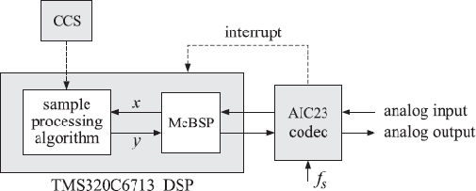

***TMS320C6713 floating point DSP***

The AIC23 codec is configured (through CCS) to operate at one of the above sampling rates fs. Each collected sample is converted to a 16-bit two’s complement integer (a **short** data type in C). The codec actually samples the audio input in stereo, that is, it collects two samples for the left and right channels

# ARCHITECTURE

The 67XX DSPs use an advanced, modified Harvard architecture that maximizes processing power by maintaining one program memory bus and three data memory buses. These processors also provide an arithmetic logic unit (ALU) that has a high degree of parallelism, application-specific hardware logic, on-chip memory, and additional on-chip peripherals. These DSP families also provide a highly specialized instruction set, which is the basis of the operational flexibility and speed of these DSPs. Separate program and data spaces allow simultaneous access to program instructions and data, providing the high degree of parallelism. Two reads and one write operation can be performed in a single cycle. Instructions with parallel store and application-specific instructions can fully utilize this architecture. In addition, data can be transferred between data and program spaces. Such parallelism supports a powerful set of arithmetic, logic, and bit-manipulation operations that can all be performed in a single machine cycle. Also included are the control mechanisms to manage interrupts, repeated operations, and function calls.

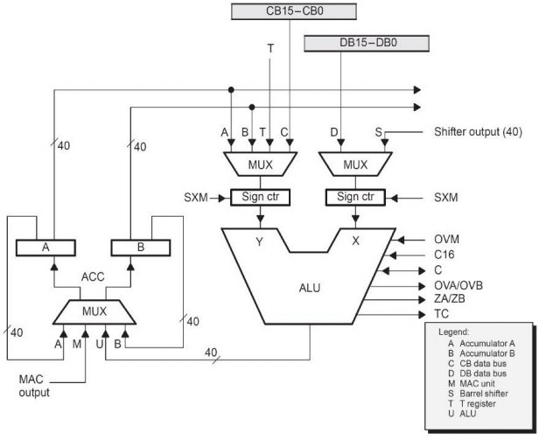

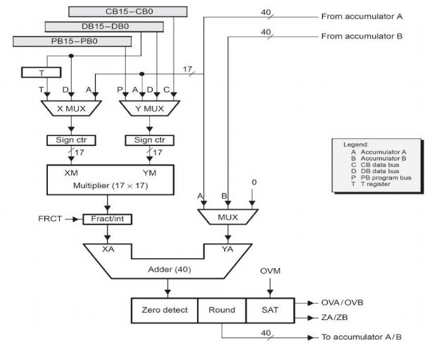

# Central Processing Unit (CPU)

The CPU of the 67XX devices contains:

‟

* + - A 40-bit arithmetic logic unit (ALU)
    - Two 40-bit accumulators
    - A barrel shifter
    - A 17 -bit multiplier/adder
    - A compare, select, and store unit (CSSU)

# Arithmetic Logic Unit (ALU)

The ‟67XX devices perform 2s-complement arithmetic using a 40-bit ALU and two 40-bit accumulators (ACCA and ACCB). The ALU also can perform Boolean operations. The ALU can function as two 16-bit ALUs and perform two 16- bit operations simultaneously when the C16 bit in status register 1 (ST1) is set.

# Accumulators

The accumulators, ACCA and ACCB, store the output from the ALU or the multiplier / adder block; the accumulators can also provide a second input to the ALU or the multiplier / adder. The bits in each accumulator are grouped as follows:

* + - Guard bits (bits 32–39)
    - A high-order word (bits 16–31)
    - A low-order word (bits 0–15)

Instructions are provided for storing the guard bits, the high-order and the low- order accumulator words in data memory, and for manipulating 32-bit accumulator words in or out of data memory. Also, any of the accumulators can be used as temporary storage for the other.

# Barrel Shifter

The ‟67XX‟s barrel shifter has a 40-bit input connected to the accumulator or data memory (CB, DB) and a 40-bit output connected to the ALU or data memory (EB). The barrel shifter produces a left shift of 0 to 31 bits and a right shift of 0 to 16 bits on the input data. The shift requirements are defined in the shift-count field (ASM) of ST1 or defined in the temporary register (TREG), which is designated as a shift-count register. This shifter and the exponent detector normalize the values in an accumulator in a single cycle. The least significant bits (LSBs) of the output are filled with 0s and the most significant bits (MSBs) can be either zero-filled or sign- extended, depending on the state of the sign-extended mode bit (SXM) of ST1.

Additional shift capabilities enable the processor to perform numerical scaling, bit extraction, extended arithmetic, and overflow prevention operations

# Multiplier/Adder

The multiplier / adder perform 17-bit 2s-complement multiplication with a 40- bit accumulation in a single instruction cycle. The multiplier / adder block consists of several elements: a multiplier, adder, signed/unsigned input control, fractional control, a zero detector, a rounder (2s-complement), overflow/saturation logic, and TREG. The multiplier has two inputs: one input is selected from the TREG, a data memory operand, or an accumulator; the other is selected from the program memory, the data memory, an accumulator, or an immediate value. The fast on-chip multiplier allows the C67XX to perform operations such as convolution, correlation, and filtering efficiently. In addition, the multiplier and ALU together execute multiply/accumulate (MAC) computations and ALU operations in parallel in a single instruction cycle. This function is used in determining the Euclid distance, and in implementing symmetrical and least mean square (LMS) filters, which are required for complex DSP algorithms.

# Compare, Select, and Store Unit (CSSU)

The compare, select, and store unit (CSSU) performs maximum comparisons between the accumulator’s high and low words, allows the test/control (TC) flag bit of status register 0 (ST0) and the transition (TRN) register to keep their transition histories, and selects the larger word in the accumulator to be stored in data memory. The CSSU also accelerates Viterbi-type butterfly computation with optimized on-chip hardware.

# Program Control

Program control is provided by several hardware and software mechanisms:

The program controller decodes instructions, manages the pipeline, stores the status of operations, and decodes conditional operations. Some of the hardware elements included in the program controller are the program counter, the status and control register, the stack, and the address-generation logic.

Some of the software mechanisms used for program control includes branches, calls, and conditional instructions, are peat instruction, reset, and interrupt.

The C67XX supports both the use of hardware and software interrupts for program control. Interrupt service routines are vectored through a re-locatable interrupt vector table. Interrupts can be globally enabled / disabled and can be

individually masked through the interrupt mask register (IMR). Pending interrupts are indicated in the interrupt flag register (IFR). For detailed information on the structure of the interrupt vector table, the IMR and the IFR, see the device-specific data sheets.

# Status Registers (ST0, ST1)

The status registers, ST0 and ST1, contain the status of the various conditions and modes for the ‟67XX devices. ST0 contains the flags (OV, C, and TC) produced by arithmetic operations and bit manipulations in addition to the data page pointer (DP) and the auxiliary register pointer (ARP) fields. ST1 contains the various modes and instructions that the processor operates on and executes.

# Auxiliary Registers (AR0–AR7)

The eight 16-bit auxiliary registers (AR0–AR7) can be accessed by the central arithmetic logic unit (CALU) and modified by the auxiliary register arithmetic units (ARAUs). The primary function of the auxiliary registers is generating 16-bit addresses for data space. However, these registers also can act as general-purpose registers or counters.

# Temporary Register (TREG)

The TREG is used to hold one of the multiplicands for multiply and multiply/accumulate instructions. It can hold a dynamic (execution-time programmable) shift count for instructions with a shift operation such as ADD, LD, and SUB. It also can hold a dynamic bit address for the BITT instruction. The EXP instruction stores the exponent value computed into the TREG, while the NORM instruction uses the TREG value to normalize the number. For ACS operation of Viterbi decoding, TREG holds branch metrics used by the DADST and DSADT instructions.

# Transition Register (TRN)

The TRN is a 16-bit register that is used to hold the transition decision for the path to new metrics to perform the Viterbi algorithm. The CMPS (compare, select, max, and store) instruction updates the contents of the TRN based on the comparison between the accumulator high word and the accumulator low word.

# Stack-Pointer Register (SP)

The SP is a 16-bit register that contains the address at the top of the system stack. The SP always points to the last element pushed onto the stack. The stack is manipulated by interrupts, traps, calls, returns, and the PUSHD, PSHM, POPD, and POPM instructions. Pushes and pops of the stack pre decrement and post increment, respectively, all 16 bits of the SP.

# Circular-Buffer-Size Register (BK)

The 16-bit BK is used by the ARAUs in circular addressing to specify the data block size.

# Block-Repeat Registers (BRC, RSA, REA)

The block-repeat counter (BRC) is a 16-bit register used to specify the number of times a block of code is to be repeated when performing a block repeat. The block- repeat start address (RSA) is a 16-bit register containing the starting address of the block of program memory to be repeated when operating in the repeat mode. The 16- bit block-repeat end address (REA) contains the ending address if the block of program memory is to be repeated when operating in the repeat mode.

# Interrupt Registers (IMR, IFR)

The interrupt-mask register (IMR) is used to mask off specific interrupts individually at required times. The interrupt-flag register (IFR) indicates the current status of the interrupts.

# Processor-Mode Status Register (PMST)

The processor-mode status registers (PMST) controls memory configurations of the 67XX devices.

# Power-Down Modes

There are three power-down modes, activated by the IDLE1, IDLE2, and IDLE3 instructions. In these modes, the 67XX devices enter a dormant state and dissipate considerably less power than in normal operation. The IDLE1instruction is used to shut down the CPU. The IDLE2 instruction is used to shut down the CPU and on-chip peripherals. The IDLE3 instruction is used to shut down the 67XX processor completely. This instruction stops the PLL circuitry as well as the CPU and peripherals.

‟

‟

# RESULT

Thus the study of architecture TMS320VC67XX and its functionalities has been identified.

# Ex. No: 8

**Date: AIM:**

**MAC OPERATION USING VARIOUS ADDRESSING MODES**

To Study the various addressing modes of TMS320C5416 XX DSP processor.

# THEORY:

Addressing Modes The TMS320C67XX DSP supports three types of addressing modes that enable flexible access to data memory, to memory-mapped registers, to register bits, and to I/O space:

The absolute addressing mode allows you to reference a location by supplying all or part of an address as a constant in an instruction.

The direct addressing mode allows you to reference a location using an address offset. The indirect addressing mode allows you to reference a location using a pointer.

Each addressing mode provides one or more types of operands. An instruction that supports an addressing-mode operand has one of the following syntax elements listed below. **Baddr**

When an instruction contains Baddr, that instruction can access one or two bits in an accumulator (AC0–AC3), an auxiliary register (AR0–AR7), or a temporary register (T0–T3). Only the register bit test/set/clear/complement instructions support Baddr. As you write one of these instructions, replace Baddr with a compatible operand.

# Cmem

When an instruction contains Cmem, that instruction can access a single word (16 bits)of data from data memory. As you write the instruction, replace Cmem with a compatible operand.

# Lmem

When an instruction contains Lmem, that instruction can access a long word (32 bits) of data from data memory or from a memory-mapped registers. As you write the instruction, replace Lmem with a compatible operand.

# Smem

When an instruction contains Smem, that instruction can access a single word (16 bits) of data from data memory, from I/O space, or from a memory-mapped register. As you write the instruction, replace Smem with a compatible operand.

# Xmem and Ymem

When an instruction contains Xmem and Ymem, that instruction can perform two simultaneous 16-bit accesses to data memory. As you write the instruction, replace Xmem and Ymem with compatible operands.

# Absolute Addressing Modes k16 absolute

This mode uses the 7-bit register called DPH (high part of the extended data page register) and a 16-bit unsigned constant to form a 23-bit data space address. This mode is used to access a memory location or a memory-mapped register.

# k23 absolute

This mode enables you to specify a full address as a 23-bit unsigned constant. This mode is used to access a memory location or a memory-mapped register.

# I/O absolute

This mode enables you to specify an I/O address as a 16-bit unsigned constant. This mode is used to access a location in I/O space.

# Direct Addressing Modes DP direct

This mode uses the main data page specified by DPH (high part of the extended data page register) in conjunction with the data page register (DP).This mode is used to access a memory location or a memory-mapped register.

# SP direct

This mode uses the main data page specified by SPH (high part of the extended stack pointers) in conjunction with the data stack pointer (SP). This mode is used to access stack values in data memory.

# Register-bit direct

This mode uses an offset to specify a bit address. This mode is used to access one register bit or two adjacent register bits.

# PDP direct

This mode uses the peripheral data page register (PDP) and an offset to specify an I/O address. This mode is used to access a location in I/O space. The DP direct and SP direct addressing modes are mutually exclusive. The mode selected depends on the CPL bit in status register ST1_67: 0 DP direct addressing mode 1 SP direct addressing mode The register-bit and PDP direct addressing modes are independent of the CPL bit.

# Indirect Addressing Modes

You may use these modes for linear addressing or circular addressing.

# AR indirect

This mode uses one of eight auxiliary registers (AR0–AR7) to point to data. The way the CPU uses the auxiliary register to generate an address depends on whether you are accessing data space (memory or memory-mapped registers), individual register bits, or I/O space.

# Dual AR indirect

This mode uses the same address-generation process as the AR indirect addressing mode. This mode is used with instructions that access two or more data-memory locations.

# CDP indirect

This mode uses the coefficient data pointer (CDP) to point to data. The way the CPU uses CDP to generate an address depends on whether you are accessing data space (memory or memory-mapped registers), individual register bits, or I/O space.

# Coefficient indirect

This mode uses the same address-generation process as the CDP indirect addressing mode. This mode is available to support instructions that can access a coefficient in data memory at the same time they access two other data-memory values using the dual AR indirect addressing mode.

# Circular Addressing

Circular addressing can be used with any of the indirect addressing modes. Each of the eight auxiliary registers (AR0–AR7) and the coefficient data pointer (CDP) can be independently configured to be linearly or circularly modified as they act as pointers to data or to register bits, see Table 3−10. This configuration is done with a bit (ARnLC) in status register ST2_67. To choose circular modification, set the bit. Each auxiliary register ARn has its own linear/circular configuration bit in ST2_67: 0 Linear addressing 1 Circular addressing The CDPLC bit in status register ST2_67 configures the DSP to use CDP for linear addressing or circular addressing: 0 Linear addressing 1 Circular addressing You can use the circular addressing instruction qualifier, .CR, if you want every pointer used by the instruction to be modified circularly, just add .CR to the end of the instruction mnemonic (for example, ADD.CR). The circular addressing instruction qualifier overrides the linear/circular configuration in ST2_67.

# ADDITION:

INP1 .SET 0H INP2 .SET 1H OUT .SET 2H

.mmregs

.text START:

LD #140H,DP RSBX CPL NOP

NOP NOP NOP

LD INP1,A ADD INP2,A STL A,OUT

HLT: B HLT

**INPUT:**

**OUTPUT:**

Data Memory: A000h 0004h A001h 0004h

Data Memory:

# A002h 0008h

**SUBTRACTION:**

INP1 .SET 0H INP2 .SET 1H OUT .SET 2H

.mmregs

.text START:

LD #140H,DP RSBX CPL NOP

NOP NOP NOP

LD INP1,A SUB INP2,A STL A,OUT

HLT: B HLT

**INPUT:**

Data Memory: **A000h 0004h A001h 0002h**

# OUTPUT:

Data Memory:

# A002h 0002h

**MULTIPLICATION**

.mmregs

.text

START:

STM #0140H,ST0

STM #40H,PMST

STM #0A000H,AR0

ST #1H,*AR0

LD *AR0+,T

ST #2H,*AR0

MPY *AR0+,A

STL A,*AR0

HLT: B HLT

.END

**OUTPUT**

A002H 2H

**DIVISION**

DIVID .SET 0H

DIVIS .SET 1H

OUT .SET 2H

.mmregs

.text

START:

STM #140H,ST0

RSBX CPL

RSBX FRCT

NOP

NOP

NOP

NOP

LD DIVID,A ;dividend to acc

RPT #0FH

SUBC DIVIS,A ;A / DIVIS -> A

STL A,OUT ;result in 9002h

HLT: B HLT

.END

**INPUT**

DATA MEMORY

A000H 000AH

A001H 0002H

**OUTPUT**

A002H 0005H

**RESULT:**

Thus, the various addressing mode of DSP processor TMS320C5416XX was studied

# Ex. No: 9

**Date: AIM:**

**WAVEFORM GENERATION**

To generate a sine wave ,square wave ,Triangular wave and Saw tooth wave using TMS320C5416XX DSP KIT.

# APPARATUS REQUIRED:

HARDWARE : Personal Computer & TMS320C67XX kit SOFTWARE : Vi Debugger

# PROCEDURE:

1. Open Code Composer Studio v4.
2. To create the New Project

Project→ New (File Name. pjt, Eg: vvits.pjt)

1. To create a Source file

File →New→ Type the code (Save & give file name, Eg: sum.asm).

1. To Add Source files to Project Project→ Add files to Project sum.asm

# COMPILE:

1. To Compile: Project→ Compile
2. To Rebuild: project → rebuild,

Which will create the final .out executable file. ( Eg. vvit.out).

1. Procedure to Lode and Run program:

Load the Program to DSK: File→ Load program →vvit.out To Execute project: Debug → Run

# PROGRAM: (Sine waveform)

mmreg

.text

START:

STM #140H,ST0

RSBX CPL

NOP

NOP

NOP

NOP

REP:

LD #TABLE,A

STM #372,AR1

LOOP:

READA DATA

PORTW DATA,04H

ADD #1H,A

B REP

**}**

**}**

**OUTPUT: ( Sine waveform)**

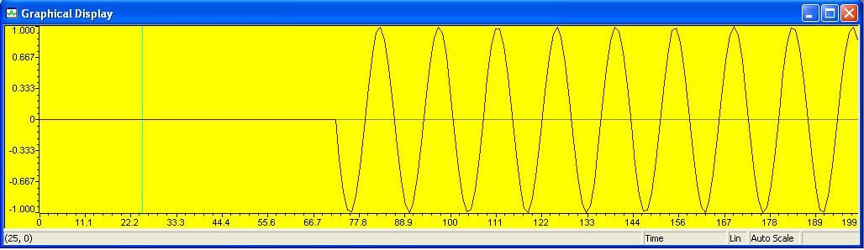

**PROGRAM: ( Square waveform)**

DATA .SET 0H

.mmregs

.text

START:

STM #140H,ST0

RSBX CPL ; NOP

NOP

NOP

NOP

REP:

ST #0H,DATA

CALL DELAY

ST #0FFFH,DATA

CALL DELAY

B REP

DELAY:

STM #0FFFH,AR1

DEL1:

PORTW DATA,04H

BANZ DEL1,*AR1-

RET

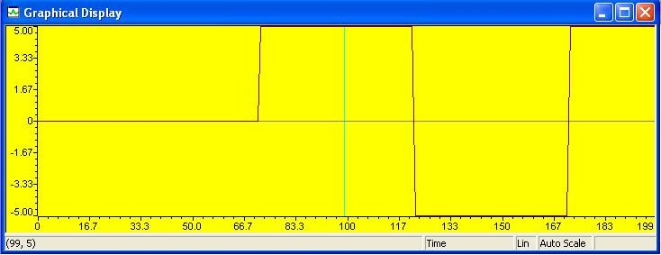

**Output**

**TRIANGULAR WAVE GENERATION**

DATA .SET 0H

.mmregs

.text

START:

STM #140H,ST0

RSBX CPL

NOP

NOP

NOP

NOP

REP:

ST #0H,DATA

INC:

LD DATA,A

ADD #1H,A

STL A,DATA

PORTW DATA,04H

CMPM DATA,#0FFFH

BC INC,NTC

DEC:

LD DATA,A

SUB #1H,A

STL A,DATA

PORTW DATA,04H

CMPM DATA,#0H

BC DEC,NTC

B REP

**SAWTOOTH WAVE GENERATION**

DATA .SET 0H

.mmregs

.text

START:

STM #140H,ST0

RSBX CPL

NOP

NOP

NOP

NOP

REP:

ST #0H,DATA

INC:

LD DATA,A

ADD #1H,A

STL A,DATA

PORTW DATA,04H

CMPM DATA,#0FFFH

BC INC,NTC

B REP

**RESULT:**

Thus, the sine wave ,square ,triangular and saw tooth waveform was generated displayed at graph.

# Ex. No: 10 Date:

**AIM:**

**DESIGN OF FIR FILTERS**

To write a ASM program for the design of FIR Filter, also plots the magnitude responses for the same.

# APPARATUS REQUIRED:

HARDWARE : Personal Computer & TMS320C67XX kit SOFTWARE : Code Composer Studio version4

# PROCEDURE:

1. Open Code Composer Studio v4.
2. To create the New Project

Project→ New (File Name.)

1. To create a Source file

File →New→ Type the code (Save & give file name, Eg: sum.asm).

1. To Add Source files to Project Project→ Add files to Projectsum.asm

# COMPILE:

1. To Compile: Project→ Compile
2. To Rebuild: project → rebuild,

Which will create the final .out executable file. ( Eg. vvit.out).

1. Procedure to Lode and Run program:

Load the Program to DSK: File→ Load program →vvit.out To Execute project: Debug → Run

**FIR-LOW-PASS FILTER**

Filter type : FIR-LPF

Window type : Rectangular window

Sampling frequency : 41khz

Cut-off frequency : 4khz

No. of taps : 52

B3 .SET 0F000H

B2 .SET 0F00H

B1 .SET 00F0H

B0 .SET 000FH

DATA .SET 50H

TXD .SET 51H

.mmregs

.text

START:

STM #01h,ST0

RSBX CPL

RSBX FRCT

NOP

NOP

STM #150H,AR1

LD #0H,A

RPT #34H

STL A,*AR1+

REPFIRL:

STM #0A200H,AR4

STM #359,AR5

LOOP:

PORTR 06,0

CHK_BUSY:

PORTR 07,0

BITF 0,#20H

BC CHK_BUSY,TC

PORTR 04,0

LD 0,A

AND #0FFFH,A

XOR #0800H,A

SUB #800H,A

STM #150H,AR1

STL A,*AR1

STM #183H,AR2

LD #0H,A

RPT #33H

MACD *AR2-,TABLE,A

STH A,1,0H

LD 0H,A

ADD #800H,A

STL A,1H

PORTW 1H,04H

STL A,*AR4+

BANZ LOOP,*AR5-

STM #0A200H,AR2

STM #359,AR3

REPSER:

STM #140H,ST0

RSBX CPL

NOP

NOP

NOP

NOP

LD *AR2+,A

SUB #7FFH,A

STL A,DATA

CALL SERIAL

BANZ REPSER,*AR3-

STM #01h,ST0

RSBX CPL

RSBX FRCT

NOP

NOP

B REPFIRL

SERIAL:

STM #140H,ST0

RSBX CPL

NOP

NOP

NOP

NOP

LD #25H,A

CALL TXDATA

STM #140H,ST0

RSBX CPL

NOP

NOP

NOP

NOP

LD DATA,A

AND #B3,A ;1st digit (from msb)

SFTL A,-12

CALL HEXASC

CALL TXDATA

STM #140H,ST0

RSBX CPL

NOP

NOP

NOP

NOP

LD DATA,A

AND #B2,A ;1st digit (from msb)

SFTL A,-8

CALL HEXASC

CALL TXDATA

STM #140H,ST0

RSBX CPL

NOP

NOP

NOP

NOP

LD DATA,A

AND #B1,A ;1st digit (from msb)

SFTL A,-4

CALL HEXASC

CALL TXDATA

STM #140H,ST0

RSBX CPL

NOP

NOP

NOP

NOP

LD DATA,A

AND #B0,A ;1st digit (from msb)

CALL HEXASC

CALL TXDATA

STM #140H,ST0

RSBX CPL

NOP

NOP

NOP

NOP

LD #24H,A

CALL TXDATA

STM #140H,ST0

RSBX CPL

NOP

NOP

NOP

NOP

RET

HEXASC:

ADD #30H,A

LD A,B

SUB #3AH,B

BC LESS9,BLT

ADD #7H,A

LESS9:

RET

TXDATA:

CALL 8C69H ;8C38H for 5416 mode 1

SSBX INTM

rpt #2ffh ;delay

nop

RET

fs = 41khz ; fc = 4khz ; N = 52

TABLE:

.word 01FH

.word 010EH

.word 01ABH

.word 01B4H

.word 0117H

.word 0H

.word 0FECDH

.word 0FDEEH

.word 0FDC2H

.word 0FE6EH

.word 0FFCDH

.word 016FH

.word 02C0H

.word 0333H

.word 0274H

.word 097H

.word 0FE19H

.word 0FBCBH

.word 0FA9BH

.word 0FB53H

.word 0FE50H

.word 0362H

.word 09C5H

.word 01048H

.word 01599H

.word 01895H

.word 01895H

.word 01599H

.word 01048H

.word 09C5H

.word 0362H

.word 0FE50H

.word 0FB53H

.word 0FA9BH

.word 0FBCBH

.word 0FE19H

.word 097H

.word 0274H

.word 0333H

.word 02C0H

.word 016FH

.word 0FFCDH

.word 0FE6EH

.word 0FDC2H

.word 0FDEEH

.word 0FECDH

.word 0H

.word 0117H

.word 01B4H

.word 01ABH

.word 010EH

.word 01FH

**FIR-HIGH PASS FIR FILTER**

Sampling freq : 43khz

Cut-off freq : 2khz

N : 52

Filter type : High pass filter

Window type : Rectangular

Program Description:

1. Make all the x(n) zero initially

2. Read the data from the adc.

3. Store the adc data in x(0)

4. Make the pointer to point the x(n_end)

5. Perform the convolution of x(n) and the coefficients h(n) using

MACD instruction.

6. Send the convolution output to the dac

7. Repeat from step 2.

.mmregs

.text

START:

STM #01h,ST0 ;intialize the data page pointer

RSBX CPL ;Make the processor to work using DP

RSBX FRCT ;reset the fractional mode bit

NOP

NOP

*****loop to make all x(n) zero initially*****

STM #150H,AR1 ;initialize ar1 to point to x(n)

LD #0H,A ;make acc zero

RPT #34H

STL A,*AR1+ ;make all x(n) zero

*****to read the adc data and store it in x(0)*****

LOOP:

PORTR 06,0 ;start of conversion

CHK_BUSY:

; PORTR 07,0 ;check for busy

; BITF 0,#20H

; BC CHK_BUSY,TC

PORTR 04,0 ;read the adc data

LD 0,A

AND #0FFFH,A ;AND adc data with 0fffh for 12 bit adc

XOR #0800H,A ;recorrect the 2's complement adc data

SUB #800H,A ;remove the dc shift

STM #150H,AR1 ;initialize ar1 with x(0)

STL A,*AR1 ;store adc data in x(0)

STM #183H,AR2 ;initialize ar2 with x(n_end)

*****start of convolution*****

LD #0H,A ;sum is 0 initially

RPT #33H

MACD *AR2-,TABLE,A ;convolution process

STH A,1,0H

LD 0H,A

ADD #800H,A ;add the dc shift to the convolution output

STL A,1H

PORTW 1H,04H ;send the output to the dac

B LOOP

TABLE:

.word 0FCEFH

.word 62H

.word 0FD50H

.word 14AH

.word 0FE1BH

.word 28FH

.word 0FF11H

.word 3E5H

.word 0FFD1H

.word 4ECH

.word 0FFF5H

.word 54FH

.word 0FF28H

.word 4DAH

.word 0FD38H

.word 398H

.word 0FA2EH

.word 1DDH

.word 0F627H

.word 55H

.word 0F131H

.word 4BH

.word 0EA6DH

.word 568H

.word 0D950H

.word 459EH

.word 459EH

.word 0D950H

.word 568H

.word 0EA6DH

.word 4BH

.word 0F131H

.word 55H

.word 0F627H

.word 1DDH

.word 0FA2EH

.word 398H

.word 0FD38H

.word 4DAH

.word 0FF28H

.word 54FH

.word 0FFF5H

.word 4ECH

.word 0FFD1H

.word 3E5H

.word 0FF11H

.word 28FH

.word 0FE1BH

.word 14AH

.word 0FD50H

.word 62H

.word 0FCEFH

**FIR-BAND PASS FIR FILTER**

Sampling freq : 43khz

Cut-off freq1 : 2khz

Cut-off freq2 : 4khz

N : 52

Filter type : Band pass filter

Window type : Rectangular

Program Description:

1. Make all the x(n) zero initially

2. Read the data from the adc.

3. Store the adc data in x(0)

4. Make the pointer to point the x(n_end)

5. Perform the convolution of x(n) and the coefficients h(n) using

MACD instruction.

6. Send the convolution output to the dac

7. Repeat from step 2.

.mmregs

.text

START:

STM #01h,ST0 ;intialize the data page pointer

RSBX CPL ;Make the processor to work using DP

RSBX FRCT ;reset the fractional mode bit

NOP

NOP

*****loop to make all x(n) zero initially*****

STM #150H,AR1 ;initialize ar1 to point to x(n)

LD #0H,A ;make acc zero

RPT #34H

STL A,*AR1+ ;make all x(n) zero

*****to read the adc data and store it in x(0)*****

LOOP:

PORTR 06,0 ;start of conversion

CHK_BUSY:

PORTR 07,0 ;check for busy

BITF 0,#20H

BC CHK_BUSY,TC

PORTR 04,0 ;read the adc data

LD 0,A

AND #0FFFH,A ;AND adc data with 0fffh for 12 bit adc

XOR #0800H,A ;recorrect the 2's complement adc data

SUB #800H,A ;remove the dc shift

STM #150H,AR1 ;initialize ar1 with x(0)

STL A,*AR1 ;store adc data in x(0)

STM #183H,AR2 ;initialize ar2 with x(n_end)

;*****start of convolution*****

LD #0H,A ;sum is 0 initially

RPT #33H

MACD *AR2-,TABLE,A ;convolution process

STH A,1,0H

LD 0H,A

ADD #800H,A ;add the dc shift to the convolution output

STL A,1H

PORTW 1H,04H ;send the output to the dac

B LOOP

TABLE:

.word 208H

.word 257H

.word 218H

.word 143H

.word 0H

.word 0FE9EH

.word 0FD7AH

.word 0FCE7H

.word 0FD08H

.word 0FDD1H

.word 0FEECH

.word 0FFE4H

.word 3DH

.word 0FFA1H

.word 0FDFCH

.word 0FB8FH

.word 0F8ECH

.word 0F6D4H

.word 0F608H

.word 0F713H

.word 0FA21H

.word 0FEE6H

.word 4A7H

.word 0A60H

.word 0EF8H

.word 1187H

.word 1187H

.word 0EF8H

.word 0A60H

.word 4A7H

.word 0FEE6H

.word 0FA21H

.word 0F713H

.word 0F608H

.word 0F6D4H

.word 0F8ECH

.word 0FB8FH

.word 0FDFCH

.word 0FFA1H

.word 3DH

.word 0FFE4H

.word 0FEECH

.word 0FDD1H

.word 0FD08H

.word 0FCE7H

.word 0FD7AH

.word 0FE9EH

.word 0H

.word 143H

.word 218H

.word 257H

.word 208H

**FIR- BAND REJECT FIR FILTER**

Sampling freq : 43khz

Cut-off freq1 : 2khz

Cut-off freq2 : 4khz

N : 52

Filter type : Band reject filter

Window type : Rectangular

Program Description:

1. Make all the x(n) zero initially

2. Read the data from the adc.

3. Store the adc data in x(0)

4. Make the pointer to point the x(n_end)

5. Perform the convolution of x(n) and the coefficients h(n) using

MACD instruction.

6. Send the convolution output to the dac

7. Repeat from step 2.

.mmregs

.text

START:

STM #01h,ST0 ;intialize the data page pointer

RSBX CPL ;Make the processor to work using DP

RSBX FRCT ;reset the fractional mode bit

NOP

NOP

;*****loop to make all x(n) zero initially*****

STM #150H,AR1 ;initialize ar1 to point to x(n)

LD #0H,A ;make acc zero

RPT #34H

STL A,*AR1+ ;make all x(n) zero

;*****to read the adc data and store it in x(0)*****

LOOP:

PORTR 06,0 ;start of conversion

CHK_BUSY:

PORTR 07,0 ;check for busy

BITF 0,#20H

BC CHK_BUSY,TC

PORTR 04,0 ;read the adc data

LD 0,A

AND #0FFFH,A ;AND adc data with 0fffh for 12 bit adc

XOR #0800H,A ;recorrect the 2's complement adc data

SUB #800H,A ;remove the dc shift

STM #150H,AR1 ;initialize ar1 with x(0)

STL A,*AR1 ;store adc data in x(0)

STM #183H,AR2 ;initialize ar2 with x(n_end)

;*****start of convolution*****

LD #0H,A ;sum is 0 initially

RPT #33H

MACD *AR2-,TABLE,A ;convolution process

STH A,1,0H

LD 0H,A

ADD #800H,A ;add the dc shift to the convolution output

STL A,1H

PORTW 1H,04H ;send the output to the dac

B LOOP

TABLE:

.word 0FEB9H

.word 14EH

.word 0FDA1H

.word 155H

.word 0FE1BH

.word 282H

.word 0FEAFH

.word 2ACH

.word 0FD35H

.word 8DH

.word 0F9D9H

.word 0FE07H

.word 0F7CCH

.word 0FEE2H

.word 0FA2FH

.word 4BAH

.word 1AH

.word 25CH

.word 420H

.word 1008H

.word 89H

.word 0D61H

.word 0F3F2H

.word 0AF9H

.word 0DB7EH

.word 045DFH

.word 045DFH

.word 0DB7EH

.word 0AF9H

.word 0F3F2H

.word 0D61H

.word 89H

.word 1008H

.word 420H

.word 25CH

.word 1AH

.word 4BAH

.word 0FA2FH

.word 0FEE2H

.word 0F7CCH

.word 0FE07H

.word 0F9D9H

.word 8DH

.word 0FD35H

.word 2ACH

.word 0FEAFH

.word 282H

.word 0FE1BH

.word 155H

.word 0FDA1H

.word 14EH

.word 0FEB9H

**RESULT:**

Thus the asm program for the design of FIR filter was plotted successfully.

# Ex. No: 11 Date:

**AIM:**

**DESIGN OF IIR FILTER**

To write a ASM program for the design of IIR Filter, also plots the magnitude

responses for the same.

# APPARATUS REQUIRED:

HARDWARE : Personal Computer & TMS320C67XX

# PROCEDURE:

1. Open Code Composer Studio v4.
2. To create the New Project

Project→ New (File Name. pjt, Eg: vvits.pjt)

1. To create a Source file

File →New→ Type the code (Save & give file name, Eg: sum.c).

1. To Add Source files to Project Project→ Add files to Project→sum.c
2. To Add rts.lib file & Hello.cmd:

Project→ Add files to Project→ rts6700.lib

Library files: rts6700.lib (Path: c:\ti\c6000\cgtools\lib\ rts6700.lib) Note: Select Object& Library in (*.o,*.l) in Type of files

1. Project→ Add files to Project →hello.cmd

CMD file - Which is common for all non real time programs. (Path: c:\ti \ tutorial\dsk6713\hello1\hello.cmd)

Note: Select Linker Command file (*.cmd) in Type of files

# COMPILE:

1. To Compile: Project→ Compile
2. To Rebuild: project → rebuild,

Which will create the final .out executable file. ( Eg. vvit.out).

1. Procedure to Lode and Run program:

Load the Program to DSK: File→ Load program →vvit. out To Execute project: Debug → Run

**IIR-LOWPASS FILTER**

Filter type : Low pass filter

Filter order : 2

Filter design type : Butterworth

Pass band attenuation : 3db

First corner freq : 0.2

Second corner freq : 0.24

Sampling freq : 50Khz

Cut-off freq : 10Khz

FROM PCDSP COEFFICIENTS

XN .SET 0H

XNM1 .SET 1H

XNM2 .SET 2H

YN .SET 3H

YNM1 .SET 4H

YNM2 .SET 5H

XN1 .SET 6H

XN1M1 .SET 7H

XN1M2 .SET 8H

YN1 .SET 9H

YN1M1 .SET 0AH

YN1M2 .SET 0BH

TEMP .SET 0CH

A10 .SET 0100H

A11 .SET 0FFA2H

A12 .SET 0032H

B10 .SET 0100H

B11 .SET 0200H

B12 .SET 0100H

.mmregs

.text

START:

STM #40H,PMST

RSBX CPL

STM #01H,ST0

RSBX FRCT

NOP

NOP

NOP

;initialize xn,x(n-1),x(n-2),yn,y(n-1),y(n-2)

ST #0H,XN

ST #0H,XNM1

ST #0H,XNM2

ST #0H,YN

ST #0H,YNM1

ST #0H,YNM2

ST #0H,XN1

ST #0H,XN1M1

ST #0H,XN1M2

ST #0H,YN1

ST #0H,YN1M1

ST #0H,YN1M2

REPEAT:

;to read data from ADC

PORTR 06,20 ;start of conversion

CHK_BUSY: ;check status

; PORTR 07,20

; BITF 20,#20H

; BC CHK_BUSY,TC

PORTR 04,20 ;read ADC data

LD 20,A

AND #0FFFH,A

XOR #0800H,A ;to correct 2's complement

SUB #800H,A

STL A,XN ;xn

STL A,TEMP

LD #0H,B ;sum = B = 0

LD #B10,A ;b0 = T

STLM A,T

MPY XN,A ;b0*xn = A

SFTL A,-8

ADD A,B ;b0*xn =B

LD #B11,A ;b0 = T

STLM A,T

MPY XNM1,A ;b0*xn = A

SFTL A,-8

ADD A,B ;b0*xn =B

LD #B12,A ;b0 = T

STLM A,T

MPY XNM2,A ;b0*xn = A

SFTL A,-8

ADD A,B ;b0*xn =B

LD #A11,A ;b0 = T

STLM A,T

MPY YNM1,A ;b0*xn = A

SFTL A,-8

SUB A,B ;b0*xn =B

LD #A12,A ;b0 = T

STLM A,T

MPY YNM2,A ;b0*xn = A

SFTL A,-8

SUB A,B ;b0*xn =B

STL B,YN

STL B,XN1

LD YNM1,A

STL A,YNM2

LD YN,A

STL A,YNM1

LD XNM1,A

STL A,XNM2

LD XN,A

STL A,XNM1

LD YN,A

ADD #800H,A

STL A,YN

PORTW YN,04H

B REPEAT

**HIGH PASS FILTER**

Filter type : High pass filter

Filter order : 2

Filter design type : Butterworth

Pass band attenuation : 3db

First corner freq : 0.2

Second corner freq : 0.24

Sampling freq : 50Khz

Cut-off freq : 10Khz

FROM PCDSP COEFFICIENTS

XN .SET 0H

XNM1 .SET 1H

XNM2 .SET 2H

YN .SET 3H

YNM1 .SET 4H

YNM2 .SET 5H

XN1 .SET 6H

XN1M1 .SET 7H

XN1M2 .SET 8H

YN1 .SET 9H

YN1M1 .SET 0AH

YN1M2 .SET 0BH

TEMP .SET 0CH

A10 .SET 0100H

A11 .SET 0FFEDH

A12 .SET 002CH

B10 .SET 0100H

B11 .SET 0FE00H

B12 .SET 0100H

.mmregs

.text

START:

STM #40H,PMST

RSBX CPL

STM #01H,ST0

RSBX FRCT

NOP

NOP

NOP

;initialize xn,x(n-1),x(n-2),yn,y(n-1),y(n-2)

ST #0H,XN

ST #0H,XNM1

ST #0H,XNM2

ST #0H,YN

ST #0H,YNM1

ST #0H,YNM2

ST #0H,XN1

ST #0H,XN1M1

ST #0H,XN1M2

ST #0H,YN1

ST #0H,YN1M1

ST #0H,YN1M2

REPEAT:

;to read data from ADC

PORTR 06,20 ;start of conversion

CHK_BUSY: ;check status

; PORTR 07,20

; BITF 20,#20H

; BC CHK_BUSY,TC

PORTR 04,20 ;read ADC data

LD 20,A

AND #0FFFH,A

XOR #0800H,A ;to correct 2's complement

SUB #800H,A

STL A,XN ;xn

STL A,TEMP

LD #0H,B ;sum = B = 0

LD #B10,A ;b0 = T

STLM A,T

MPY XN,A ;b0*xn = A

SFTL A,-8

ADD A,B ;b0*xn =B

LD #B11,A ;b0 = T

STLM A,T

MPY XNM1,A ;b0*xn = A

SFTL A,-8

ADD A,B ;b0*xn =B

LD #B12,A ;b0 = T

STLM A,T

MPY XNM2,A ;b0*xn = A

SFTL A,-8

ADD A,B ;b0*xn =B

LD #A11,A ;b0 = T

STLM A,T

MPY YNM1,A ;b0*xn = A

SFTL A,-8

SUB A,B ;b0*xn =B

LD #A12,A ;b0 = T

STLM A,T

MPY YNM2,A ;b0*xn = A

SFTL A,-8

SUB A,B ;b0*xn =B

STL B,YN

STL B,XN1

LD YNM1,A

STL A,YNM2

LD YN,A

STL A,YNM1

LD XNM1,A

STL A,XNM2

LD XN,A

STL A,XNM1

LD YN,A

ADD #800H,A

STL A,YN

PORTW YN,04H

B REPEAT

**BAND PASS FILTER**

Filter type : Band pass filter

Filter order : 2

Filter design type : Chebyshev-I

Pass band attenuation : 3db

Edge frequencies:

f1 : 0.1

f2 : 0.125

f3 : 0.15

f4 : 0.175

Sampling freq : 50Khz

Cut-off freq1 : 5Khz

Cut-off freq2 : 7.5Khz

FROM PCDSP COEFFICIENTS

XN .SET 0H

XNM1 .SET 1H

XNM2 .SET 2H

YN .SET 3H

YNM1 .SET 4H

YNM2 .SET 5H

XN1 .SET 6H

XN1M1 .SET 7H

XN1M2 .SET 8H

YN1 .SET 9H

YN1M1 .SET 0AH

YN1M2 .SET 0BH

TEMP .SET 0CH

A10 .SET 0100H

A11 .SET 0FECBH

A12 .SET 00DAH

B10 .SET 0100H

B11 .SET 0000H

B12 .SET 0FF00H

.mmregs

.text

START:

STM #40H,PMST

RSBX CPL

STM #01H,ST0

RSBX FRCT

NOP

NOP

NOP

;initialize xn,x(n-1),x(n-2),yn,y(n-1),y(n-2)

ST #0H,XN

ST #0H,XNM1

ST #0H,XNM2

ST #0H,YN

ST #0H,YNM1

ST #0H,YNM2

ST #0H,XN1

ST #0H,XN1M1

ST #0H,XN1M2

ST #0H,YN1

ST #0H,YN1M1

ST #0H,YN1M2

REPEAT:

;to read data from ADC

PORTR 06,20 ;start of conversion

CHK_BUSY: ;check status

PORTR 07,20

BITF 20,#20H

BC CHK_BUSY,TC

PORTR 04,20 ;read ADC data

LD 20,A

AND #0FFFH,A

XOR #0800H,A ;to correct 2's complement

SUB #800H,A

STL A,XN ;xn

STL A,TEMP

LD #0H,B ;sum = B = 0

LD #B10,A ;b0 = T

STLM A,T

MPY XN,A ;b0*xn = A

SFTL A,-8

ADD A,B ;b0*xn =B

LD #B11,A ;b0 = T

STLM A,T

MPY XNM1,A ;b0*xn = A

SFTL A,-8

ADD A,B ;b0*xn =B

LD #B12,A ;b0 = T

STLM A,T

MPY XNM2,A ;b0*xn = A

SFTL A,-8

ADD A,B ;b0*xn =B

LD #A11,A ;b0 = T

STLM A,T

MPY YNM1,A ;b0*xn = A

SFTL A,-8

SUB A,B ;b0*xn =B

LD #A12,A ;b0 = T

STLM A,T

MPY YNM2,A ;b0*xn = A

SFTL A,-8

SUB A,B ;b0*xn =B

STL B,YN

STL B,XN1

LD YNM1,A

STL A,YNM2

LD YN,A

STL A,YNM1

LD XNM1,A

STL A,XNM2

LD XN,A

STL A,XNM1

LD YN,A

ADD #800H,A

STL A,YN

PORTW YN,04H

B REPEAT

**RESULT:**

Thus the asm program for the design of IIR filter were plotted successfully.

**Ex No: 12**

**Date :**

**DECIMATION**

PROGRAM DESCRIPTION:

In this program the sampling rate at the input is 40Khz. This input sampling rate is reduced by a factor of 2 at the output. For this, the auxillary register AR3 is loaded with the value of 2 initially. Then the output of the FIR filter is sent out to the dac only once out of 2 outputs.i.e whenever the register AR3 becomes 0, the filter output is sent to the dac and reloaded with 2. where 2 is the decimation factor of this decimator.

B3 .SET 0F000H

B2 .SET 0F00H

B1 .SET 00F0H

B0 .SET 000FH

DATA .SET 50H

TXD .SET 51H

.mmregs

.text

START:

STM #01h,ST0 ;initialize the data page pointer

RSBX CPL ;make the processor to work using DP

RSBX FRCT ;reset the fractional mode bit

NOP

NOP

NOP

NOP

STM #150H,AR1 ;initialize AR1 with x(n)

LD #0H,A ;make acc. zero

RPT #34H

STL A,*AR1+ ;make all x(n) zero

STM #2H,AR3 ;load the decimation factor

REPDECI:

STM #0A200H,AR4

STM #2159,AR5

*****starting of the filter*****

LOOP:

PORTR 06,0 ;start of conversion

CHK_BUSY:

PORTR 07,0 ; check for busy

BITF 0,#20H

BC CHK_BUSY,TC

PORTR 04,0 ;read the adc data

LD 0,A

AND #0FFFH,A ;AND adc data with 0fffh for 12 bit adc.

XOR #0800H,A ;recorrect the 2's complement adc output.

SUB #800H,A ;remove the dc shift.

STM #150H,AR1 ;initialize ar1 with x(0)

STL A,*AR1 ;store the adc data in x(0)

STM #183H,AR2 ;initialize ar2 with x(n)

*****start of convolution*****

LD #0H,A ;initialize the sum as zero

RPT #33H

MACD *AR2-,TABLE,A ;convolution operation

STH A,1,0H

LD 0H,A

ADD #800H,A ;add the dc shift

STL A,1H

BANZ NO_OUT,*AR3- ;send the filter output only if ar3 is 0.

PORTW 1H,04H

STL A,*AR4+

STM #2H,AR3 ;reinitialize ar3 with decimation factor.

B DECI_END

B LOOP

NO_OUT:

NOP

NOP

NOP

B LOOP ;repeat the above.

DECI_END:

BANZ LOOP,*AR5

STM #140H,ST0

RSBX CPL

NOP

NOP

NOP

NOP

STM #0A200H,AR4

STM #359,AR5

REPSER:

LD *AR4+,A

SUB #2048,A

STL A,DATA

CALL SERIAL

STM #140H,ST0

RSBX CPL

NOP

NOP

NOP

NOP

BANZ REPSER,*AR5-

STM #01h,ST0 ;initialize the data page pointer

RSBX CPL ;make the processor to work using DP

RSBX FRCT ;reset the fractional mode bit

NOP

NOP

NOP

NOP

B REPDECI

HLT: B HLT

SERIAL:

STM #140H,ST0

RSBX CPL

NOP

NOP

NOP

NOP

LD #25H,A

CALL TXDATA

STM #140H,ST0

RSBX CPL

NOP

NOP

NOP

NOP

LD DATA,A

AND #B3,A ;1st digit (from msb)

SFTL A,-12

CALL HEXASC

CALL TXDATA

STM #140H,ST0

RSBX CPL

NOP

NOP

NOP

NOP

LD DATA,A

AND #B2,A ;1st digit (from msb)

SFTL A,-8

CALL HEXASC

CALL TXDATA

STM #140H,ST0

RSBX CPL

NOP

NOP

NOP

NOP

LD DATA,A

AND #B1,A ;1st digit (from msb)

SFTL A,-4

CALL HEXASC

CALL TXDATA

STM #140H,ST0

RSBX CPL

NOP

NOP

NOP

NOP

LD DATA,A

AND #B0,A ;1st digit (from msb)

CALL HEXASC

CALL TXDATA

STM #140H,ST0

RSBX CPL

NOP

NOP

NOP

NOP

LD #24H,A

CALL TXDATA

STM #140H,ST0

RSBX CPL

NOP

NOP

NOP

NOP

RET

HEXASC:

ADD #30H,A

LD A,B

SUB #3AH,B

BC LESS9,BLT

ADD #7H,A

LESS9:

RET

TXDATA:

CALL 8C69H ;8C38H for 5416 mode 1

SSBX INTM

rpt #2ffh ;delay

nop

RET

TABLE:

.word 01FH

.word 010EH

.word 01ABH

.word 01B4H

.word 0117H

.word 0H

.word 0FECDH

.word 0FDEEH

.word 0FDC2H

.word 0FE6EH

.word 0FFCDH

.word 016FH

.word 02C0H

.word 0333H

.word 0274H

.word 097H

.word 0FE19H

.word 0FBCBH

.word 0FA9BH

.word 0FB53H

.word 0FE50H

.word 0362H

.word 09C5H

.word 01048H

.word 01599H

.word 01895H

.word 01895H

.word 01599H

.word 01048H

.word 09C5H

.word 0362H

.word 0FE50H

.word 0FB53H

.word 0FA9BH

.word 0FBCBH

.word 0FE19H

.word 097H

.word 0274H

.word 0333H

.word 02C0H

.word 016FH

.word 0FFCDH

.word 0FE6EH

.word 0FDC2H

.word 0FDEEH

.word 0FECDH

.word 0H

.word 0117H

.word 01B4H

.word 01ABH

.word 010EH

.word 01FH

**RESULT:**

Thus the asm program for the design of decimated were successfully.

**VIVA QUESTIONS**

1. What is MATLAB?

2. What are the applications of MATLAB?

3. State sampling theorem.

4. What is energy signal? How to calculate energy of a signal?

5.What is power signal? How to calculate power of a signal?

6.Explain linear convolution and circular convolution.

7.What are Fourier series and Fourier transform?

8.Differentiate between DTFT and DFT. Why it is advantageous to use DFT in computers rather than

DTFT?

9.What is meant by correlation?

10.Differentiate between IIR filters and FIR filters.

11.What is the procedure to design a digital Butterworth filter?

12.What is the difference between Butterworth, Chebyshev I and Chebyshev II filters?

13.What is a Digital Signal Processor (DSP)?

14.Differentiate between floating point DSP and fixed point DSP.